ASE INSEM LAB-1

Name: K Dheeran
Roll No: 2420090149
Sec: 6
Set: 5

LAB TASK -2 Q6

Create a folder names ASE INSEM Lab Q6
Inside that folder create a file Indx.html
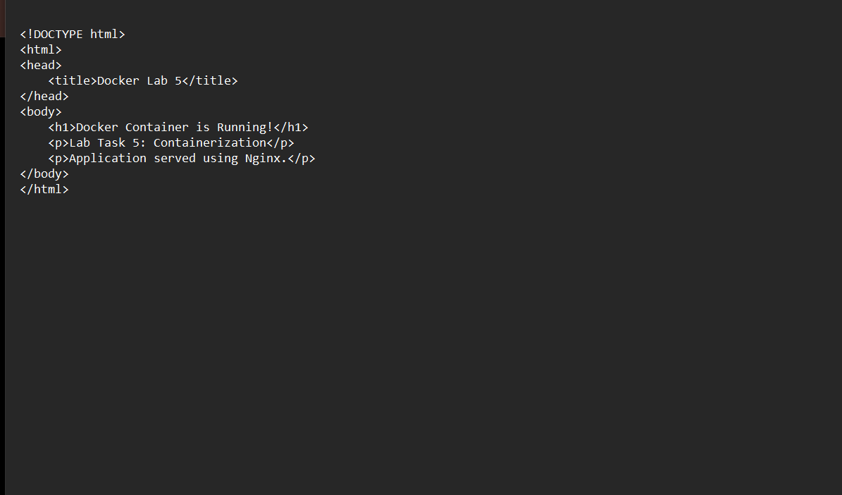
Now create another file dockerfile
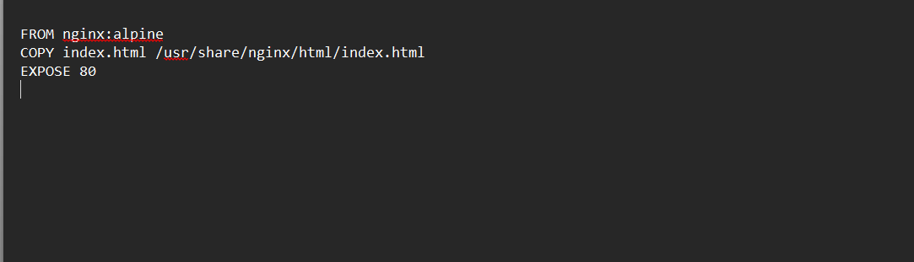
Now open docker desktop
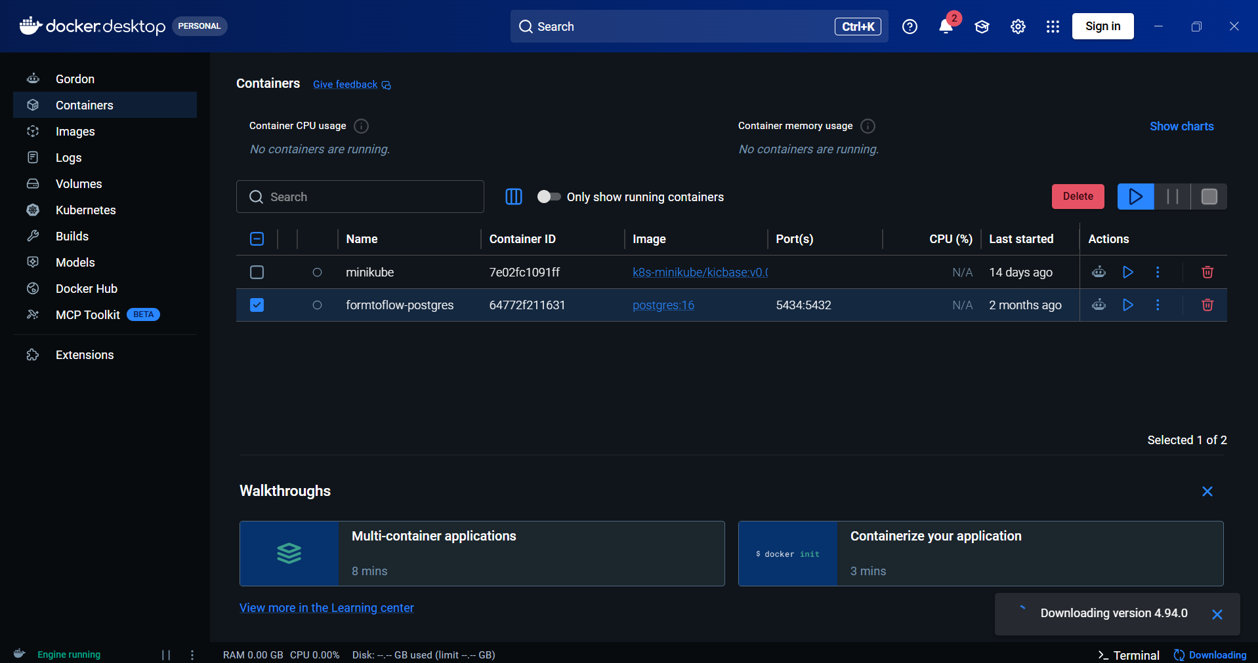
Open powershell
Enter
docker build -t docker-lab5 .
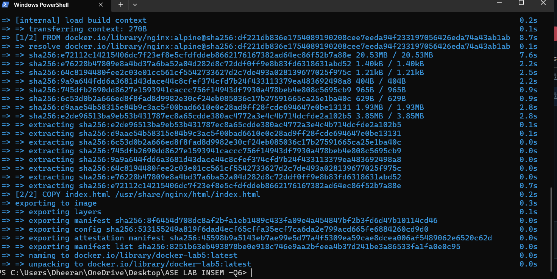
Next run this command
Run docker
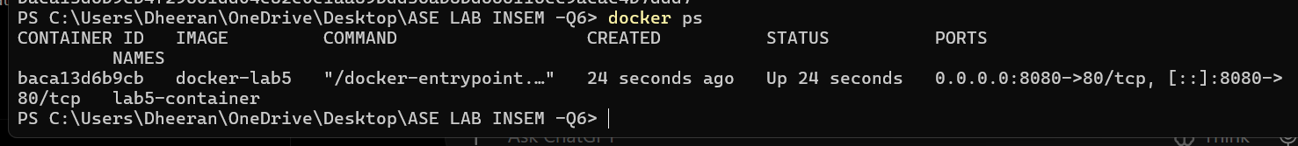
Run local host at port no 8080



